**Day 1:Activities**

1. Creation of Salesforce Developer Org.
2. Activating Account in Salesforce
3. Logging into the account and intiallizing the task

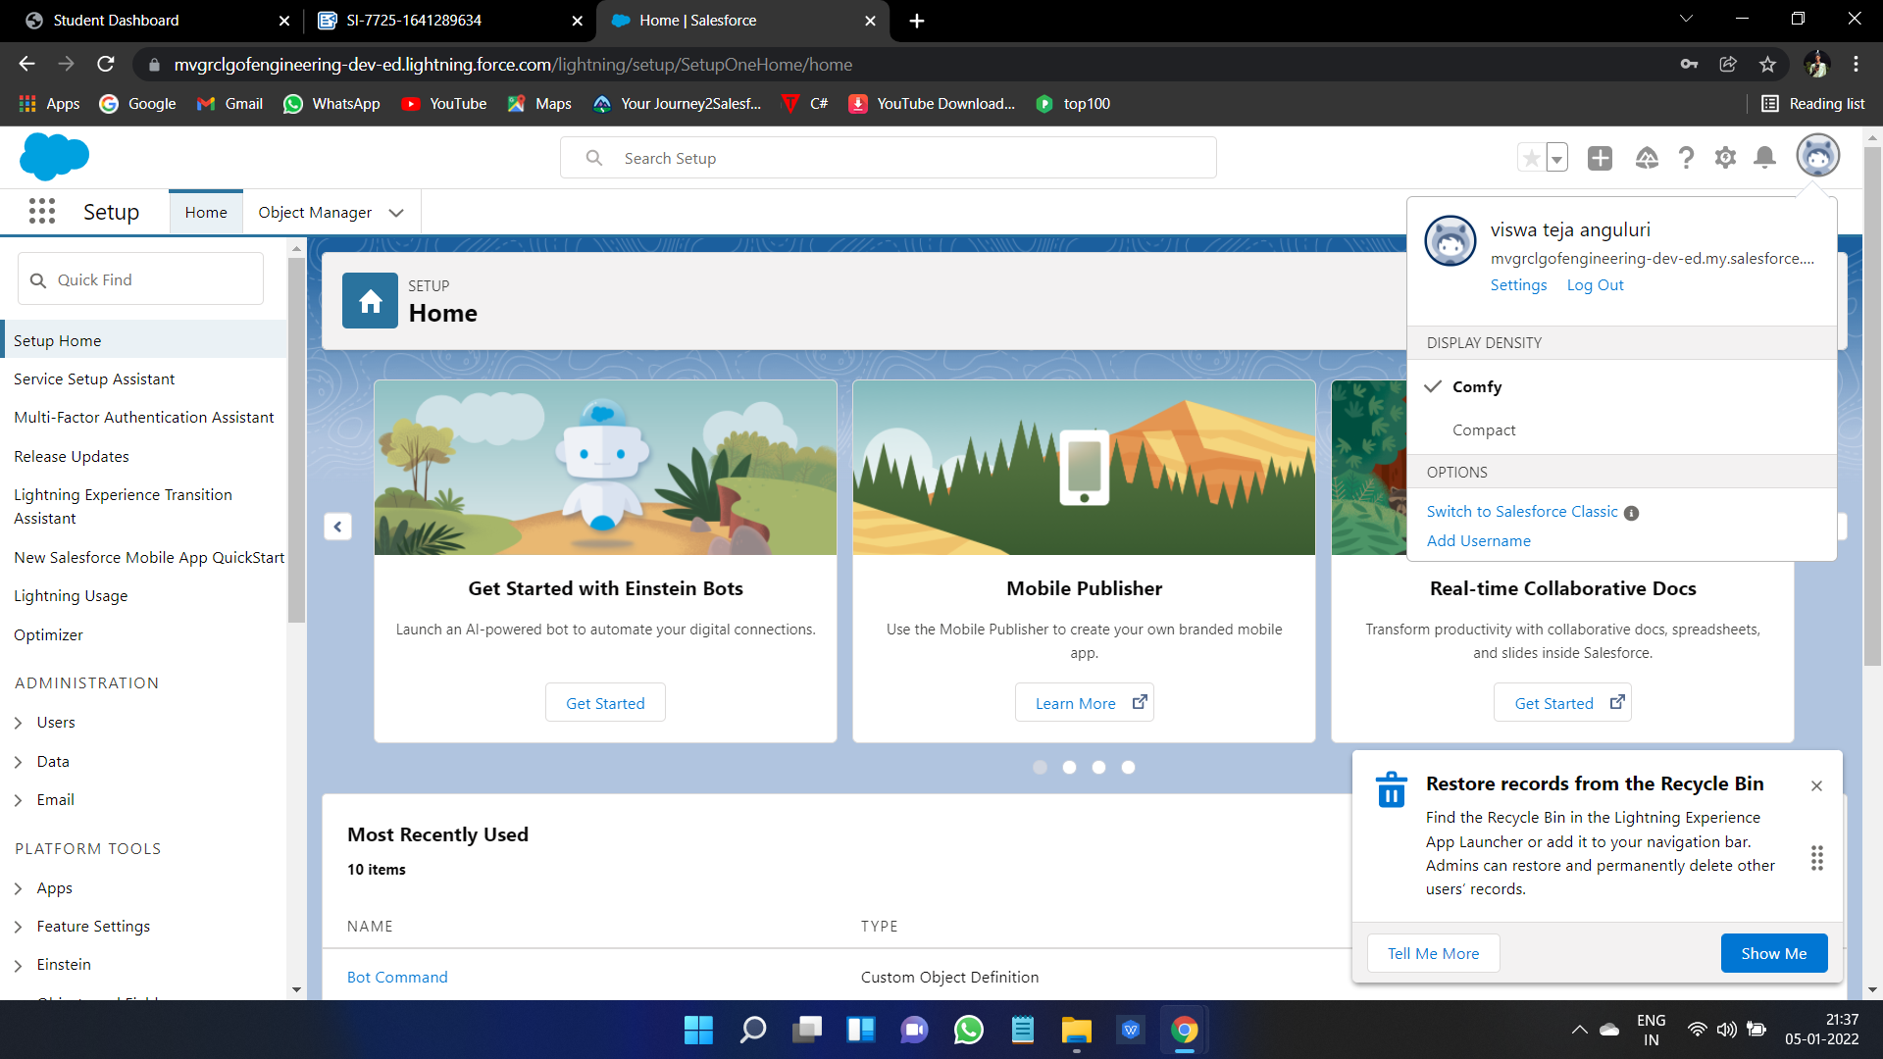

**Day 2 :Activities**

* Created Few Custom Objects in Environment Named as College Information Such as.
* College
* Application Form
* Student
* Subject
* After Creating These Custom Object Fields Respective To The Objects are Created.

**1.College** (Custom Object)

* Record Info (Text Date Type)
* Colleges Fees (Currency Data Type)
* Hostel Fees (Currency Data Type )
* College Name(Picklist Date Type)
* Email(Pickllist Date Type )
* Capacity Of Student(Picklist Data Type)

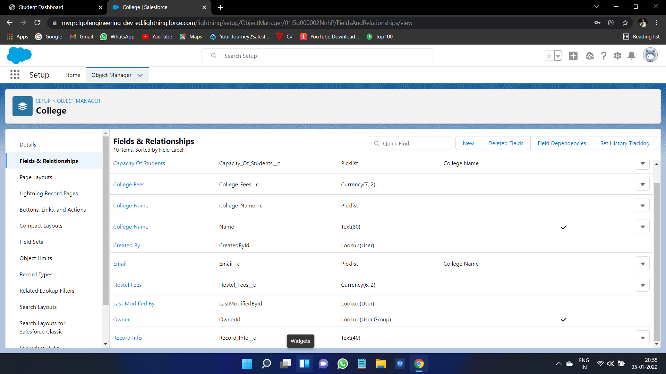

**2.Application Form**

* Applications Form ID(Autonumber Data Type)
* Address (Text Data Type)
* College (Master -Detail Relationship With College)
* College Fees(Current Data Type)
* Hostel Fees (Current Data Type)
* Date Of Birth(Date Date Type)
* Email(Email Data Type )
* Gurdian Name (Text Data Type)
* Looking For Hostel Stay(CheckBox Data Type)
* Ready to Join (CheckBox Data Type)
* Student Name (Text Data Type )
* Phone(Phone Data Type)

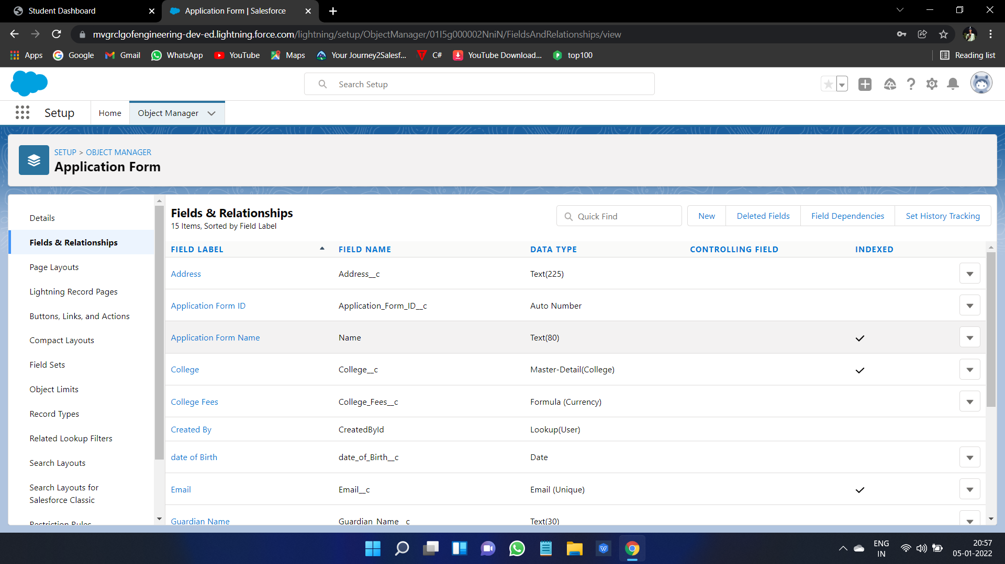

**3**.**Student**

* Student Name (Text Data Type)
* Address(Text Data Type)
* Application Form(Lookup Relationship with Application Form)
* College Name(Formula With Text Return Type)
* Date Of Birth(Date Data Type)
* Gurdian Name(Text Data Type)
* Phone(Phone Data Type)

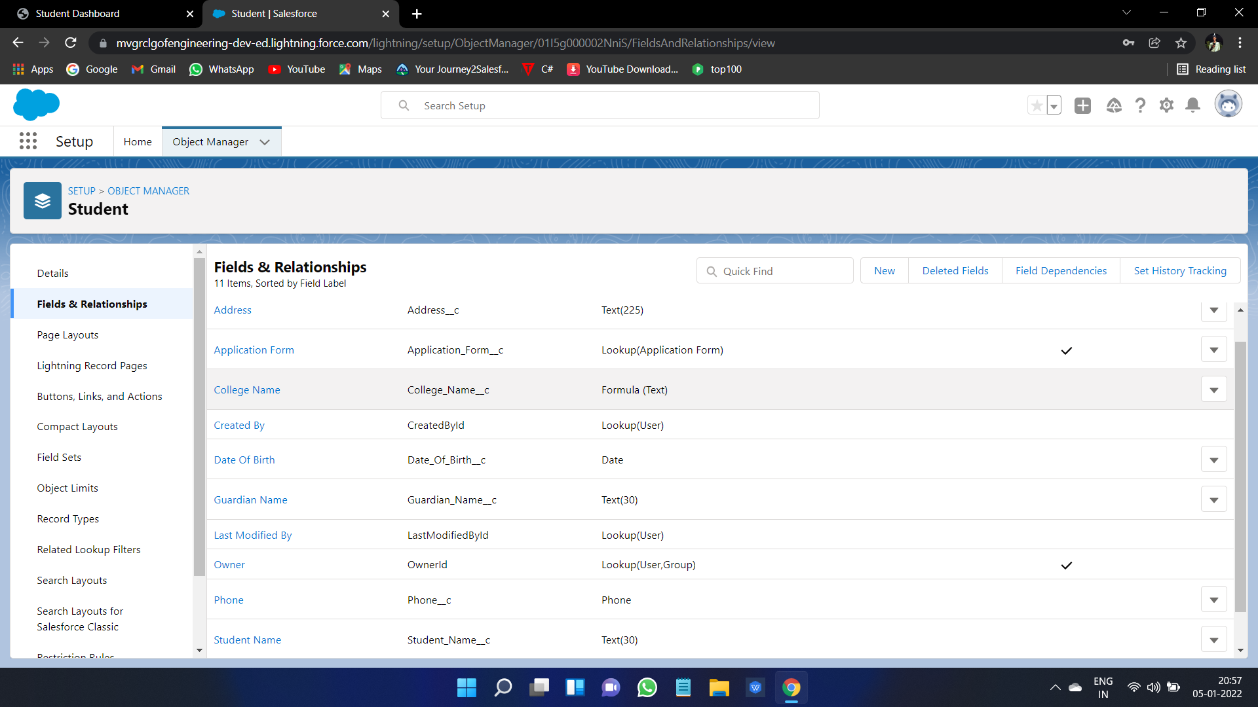

**4.Subject**

* Subject ID(AutoNumber Data Type)
* Paper1(Picklist Which Values are drawn from Global Picklist)
* Paper2(Picklist Which Values are drawn from Global Picklist)
* Student(Lookup Relationship With Student)

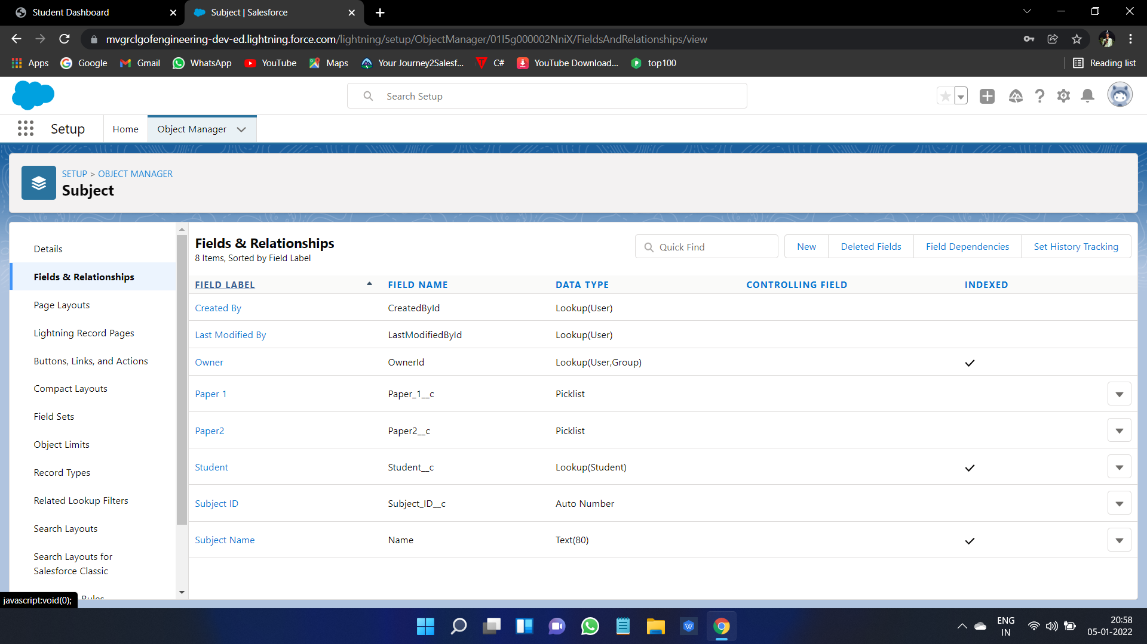

* After all, Creation of few Global Picklist Values Which are used in above Picklist Fields Like College Name ,Paper1,paper2
* Global Picklist are
* College .
* Paper1.
* Paper2.

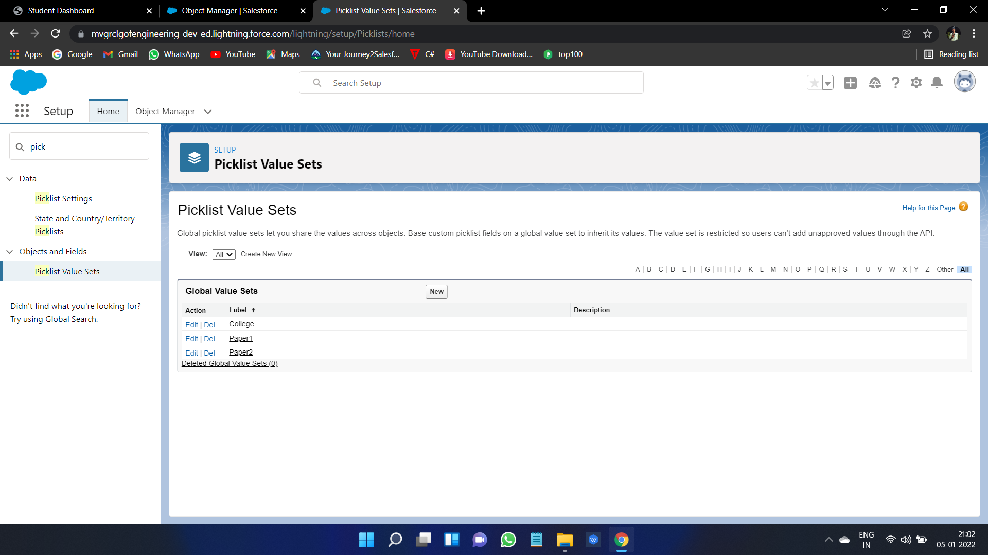

* Creation of Field Dependency in College Object between College Name and Email Where Could be the College Name Controlling and Email is Dependent Based on College name,Email restricted.
* Creation of Another Feild Dependency in college Object betwwen College Name and Capacity of Students is dependent.

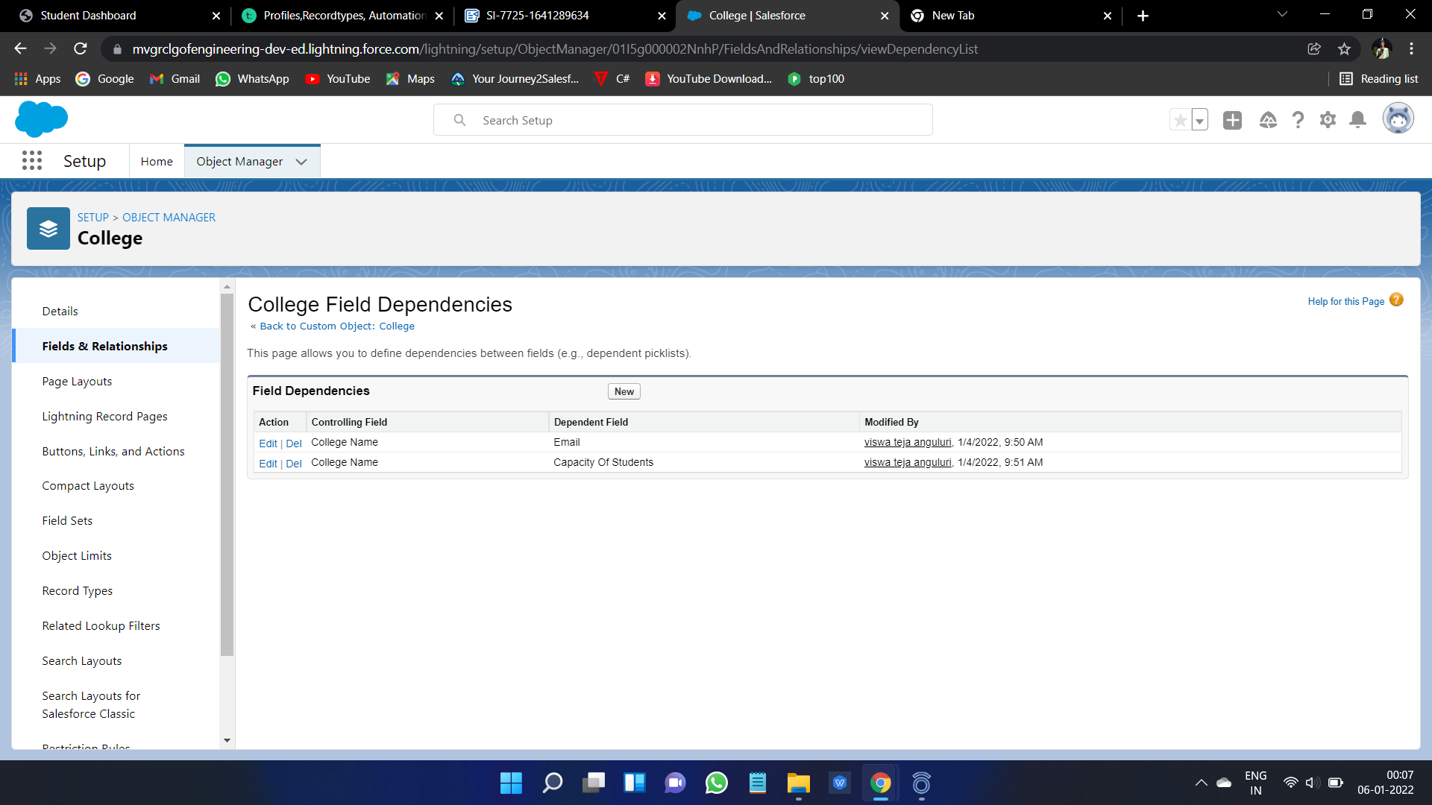

* Now Creation of Validation Rule with a Logic that checks for College Name and Record info are Same or Not
* Now Creation of Validation Rule With alogic that checks for College Name and Record info are same or not

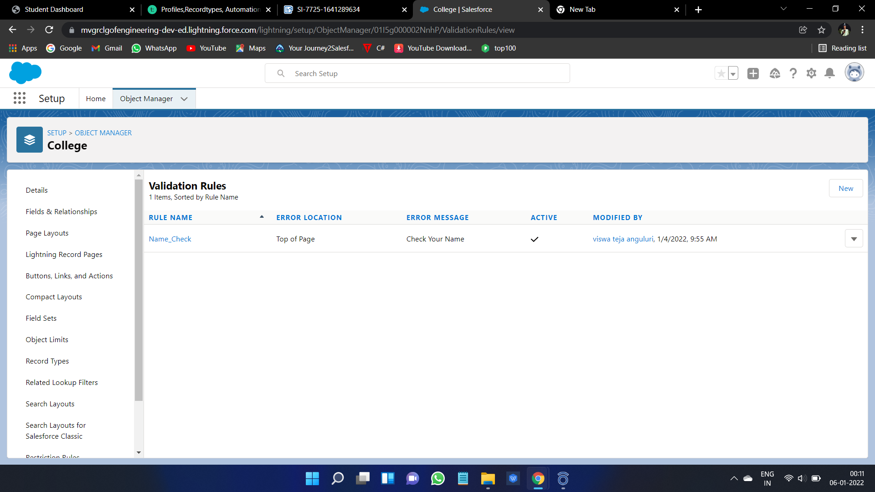

**Day 3: Activities**

* Creation of New Automation Process in Such a Way that Student Records Should be Created When We Check the Ready to Join Field in Application Form.
* Triggering Criteria is When Ready To Join Field is Checked.
* After, the Immediate Action is to Creation of Record of Student type With all the Fields Created in Student Object

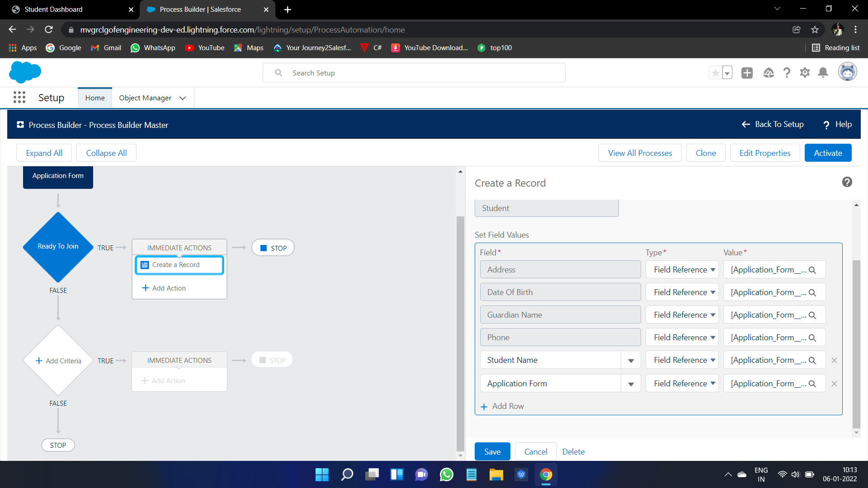

**Day4 :Activities**

* Creations of Student Record Using Flows Before we do This Process deactivate the previously created Process Automation Process
* And now Create New Flow in Flows That is related to Record trigger flow and select object Application
* Now Create Variabe name Student Resource
* Now Add Create the record

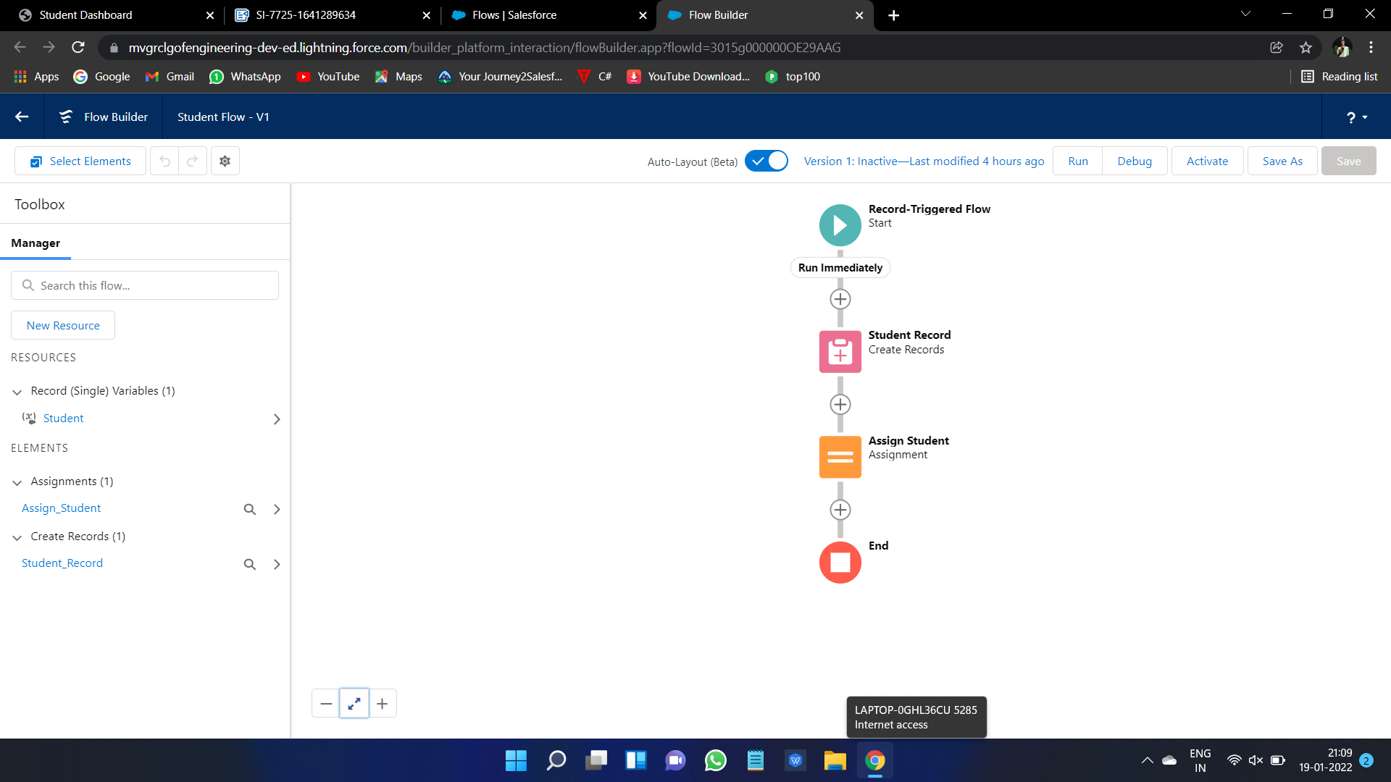

**Day5: Activities**

* Create an Apex Class With an name of Applications Batch Test Implentation of Batch able and use the needed conditions in Apex as Follows.
* Another apex Class for Scheduling the Apex With required conditions as started below and Schedule the Apex in Apex Class with requirement.

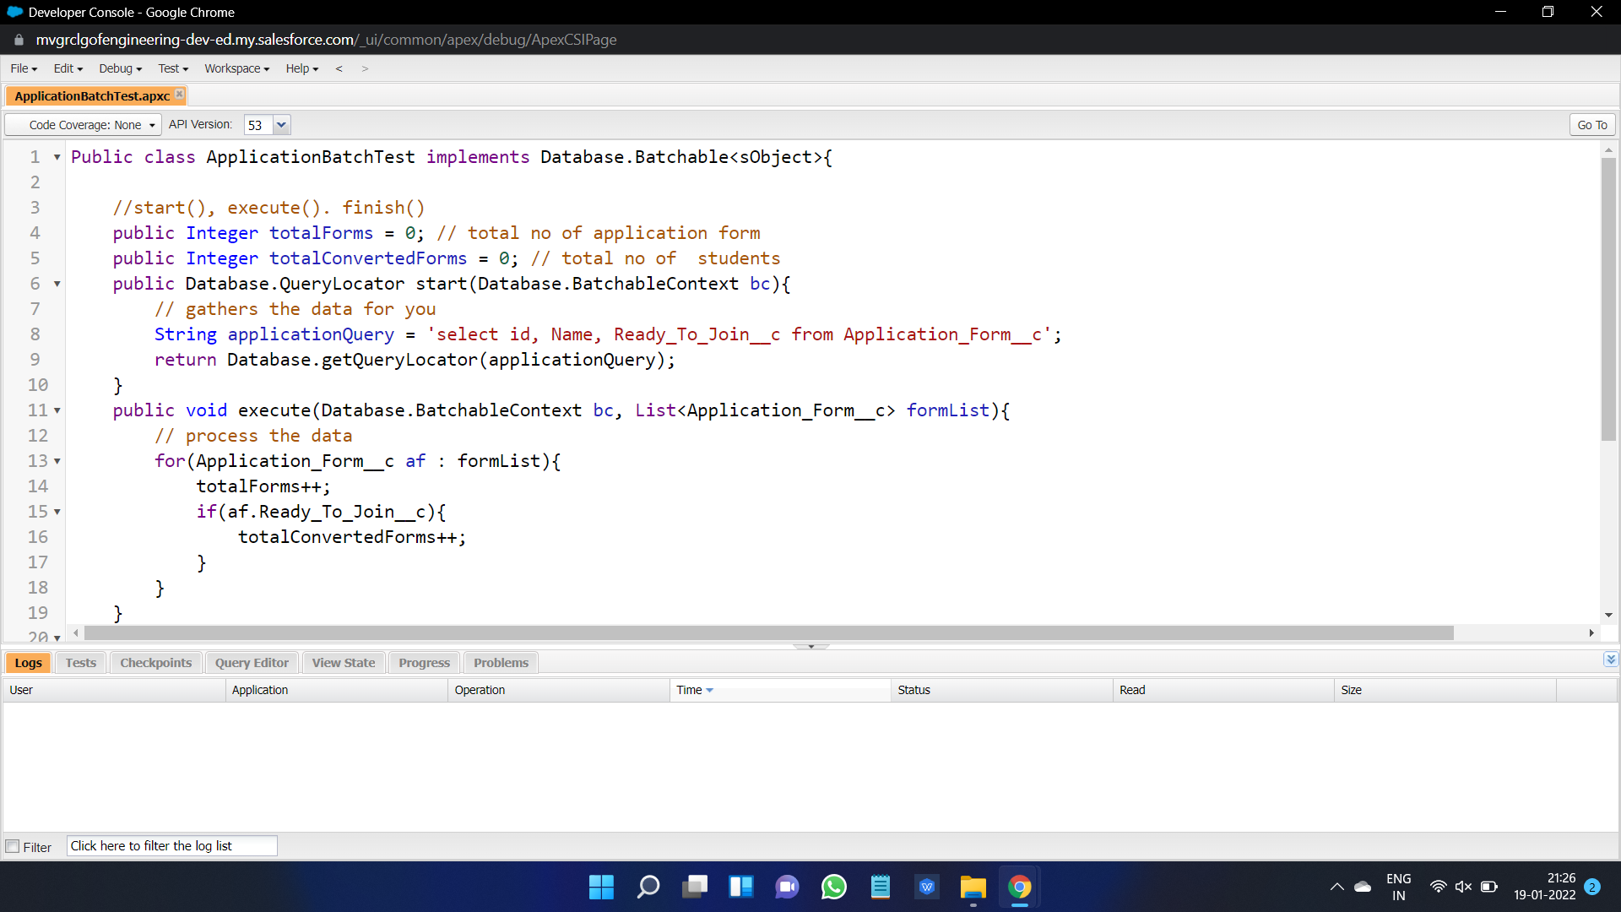

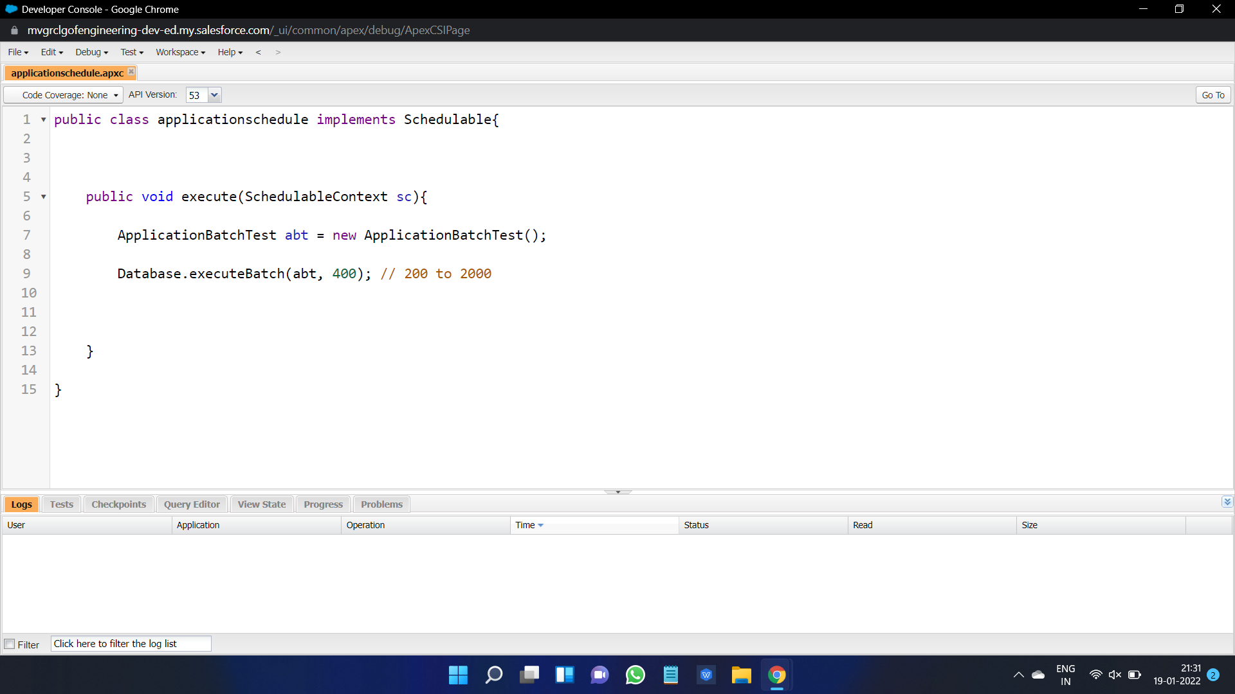

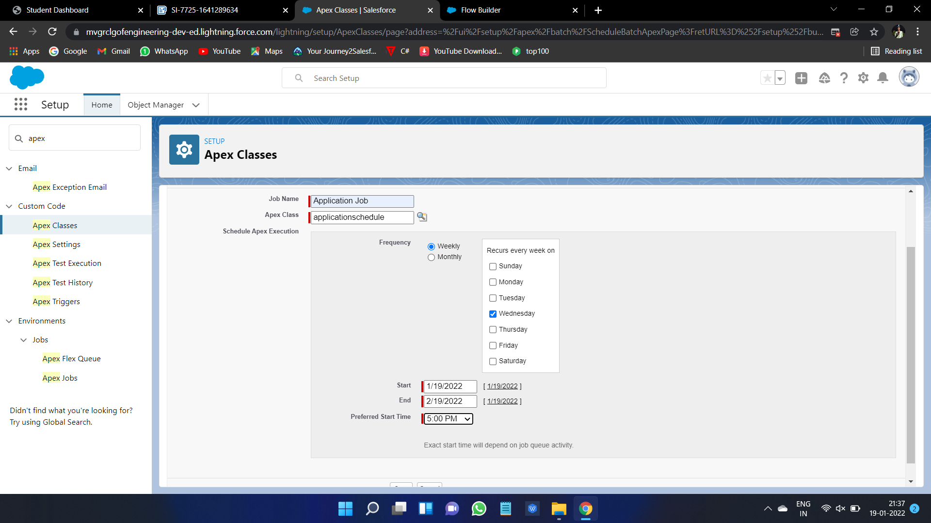

**Day6: Activities**

* Created an CollegeData Table Component with Record Page Home Page and App Page.
* Created an Apex Class in LWC with name as GetapplicationDetails with Conditions.
* After creating the collegeData Table ,code and complete the html,js,meta fiels with specified or needed Conditions as done below
* Before Completing Above Add the LWC Salesforce Editor to chrome and the go on with Procedure

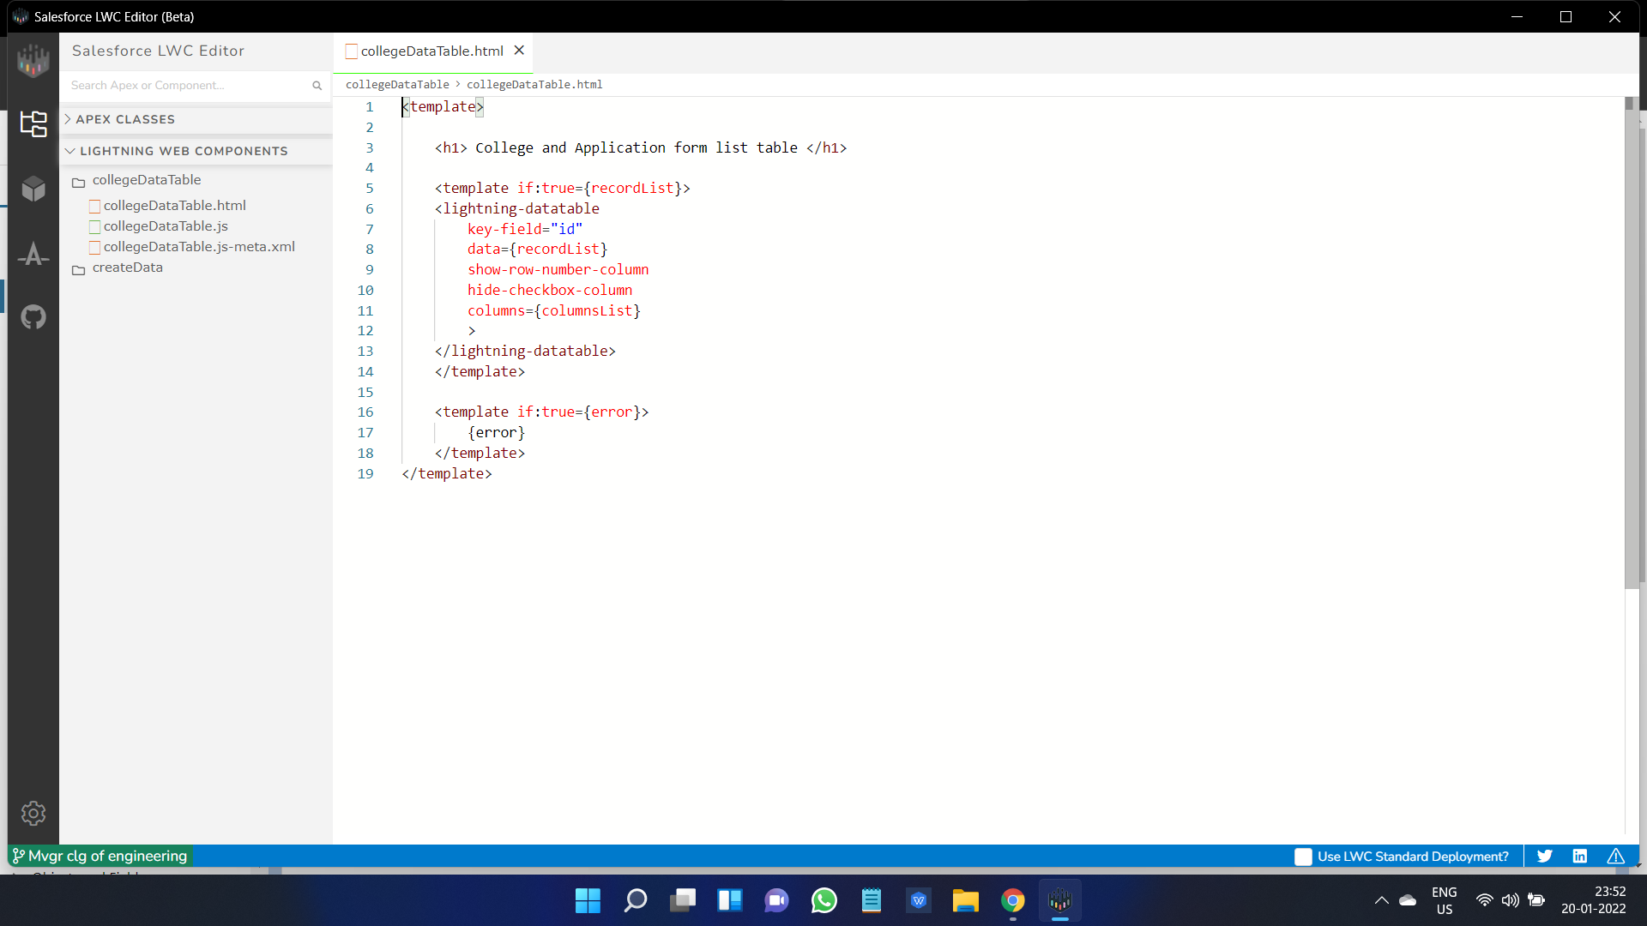

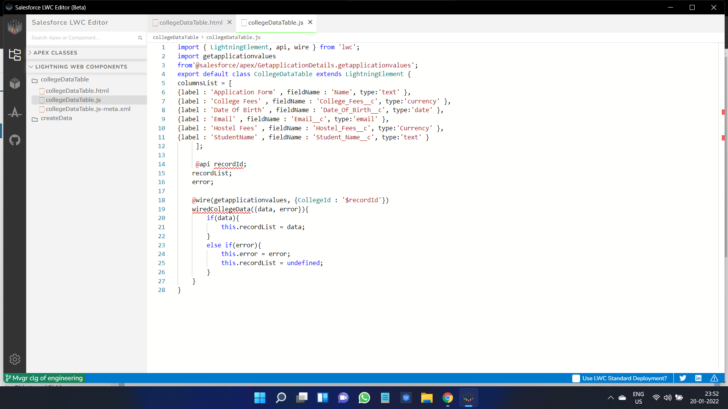

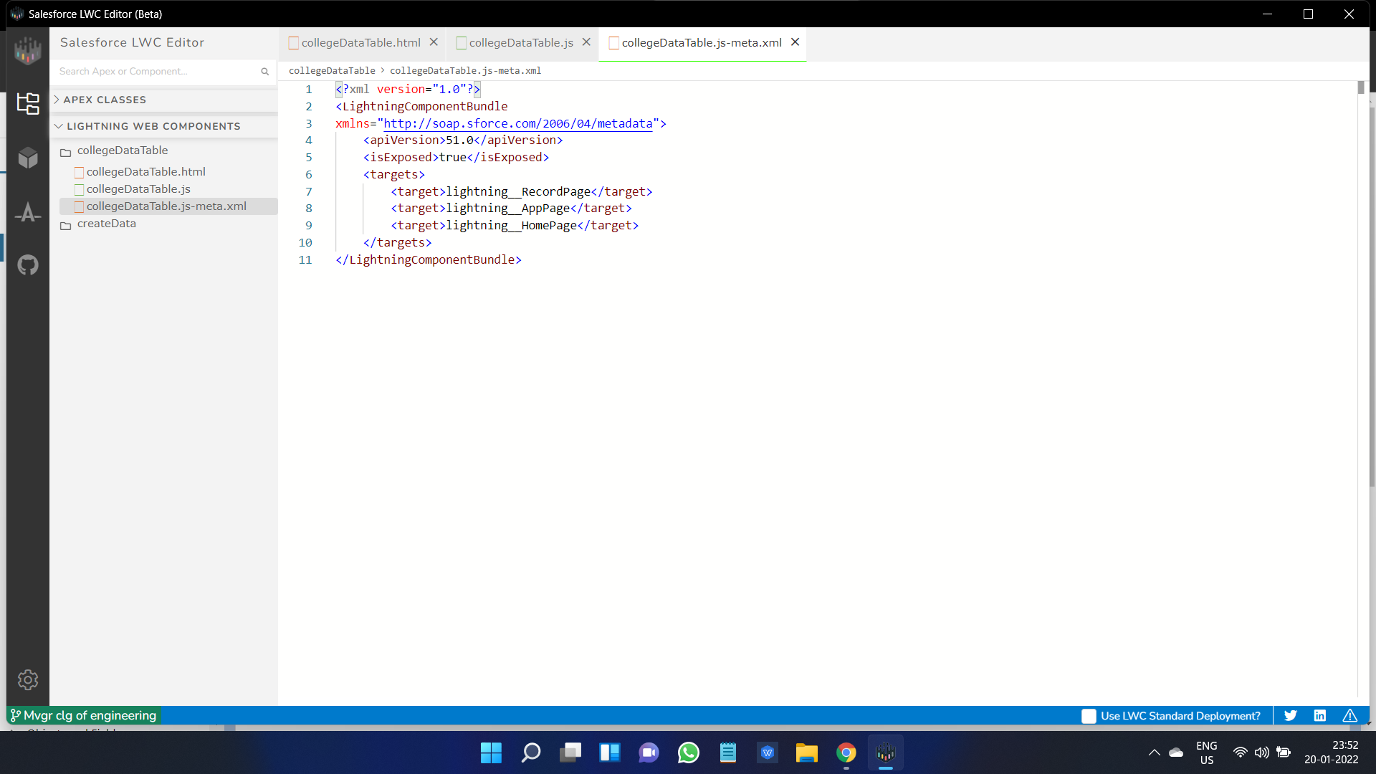

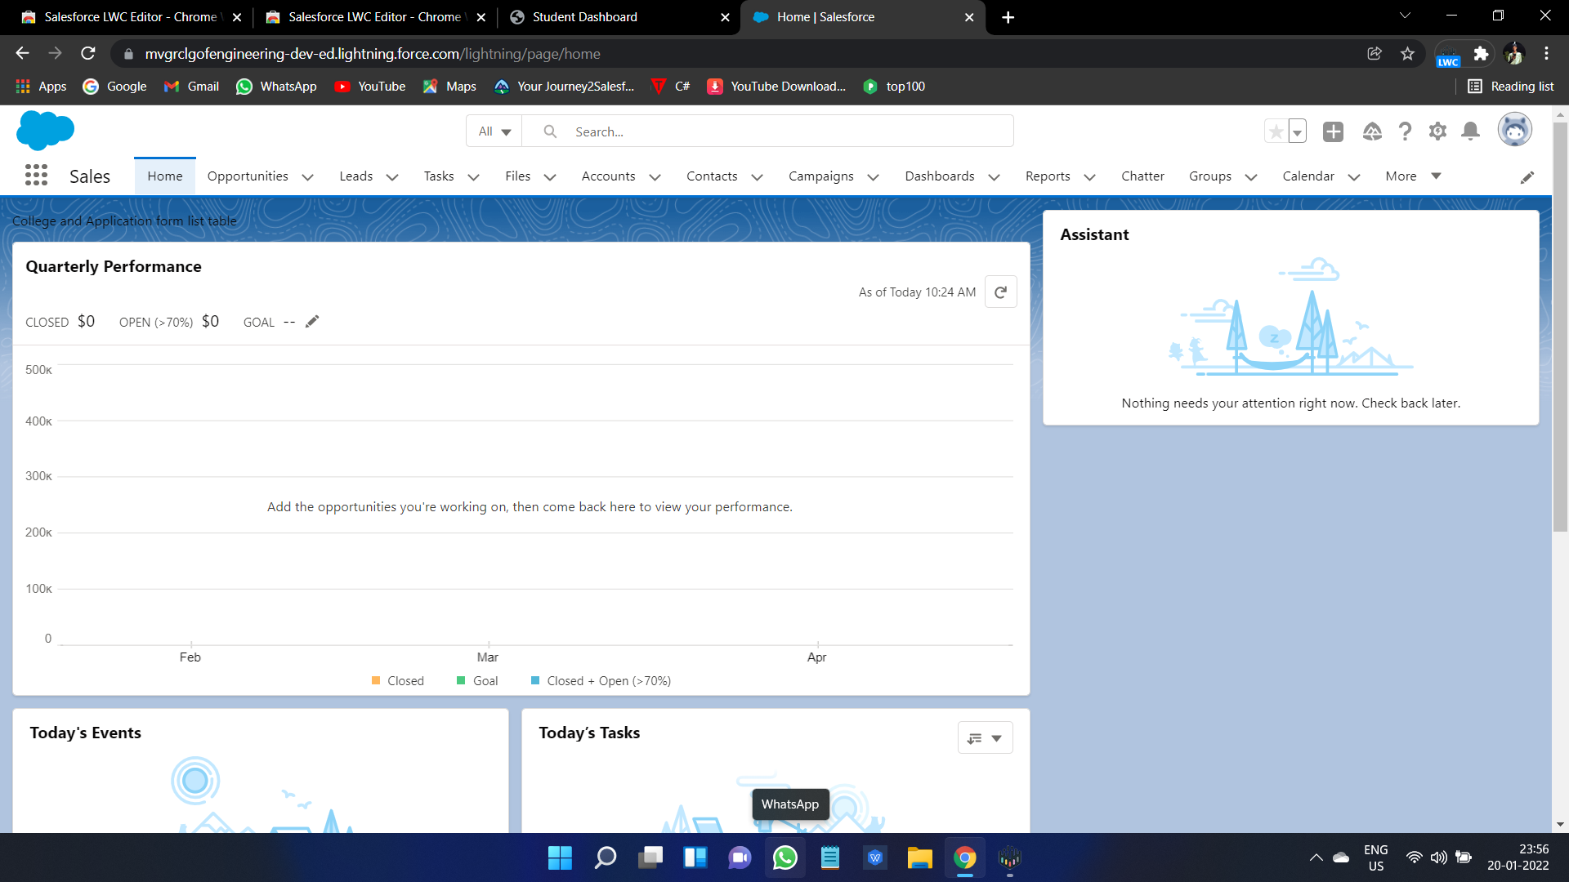

* After Doing all these check the result as data table which will be show with Fields given and Specified and the data shown aas started as below